OS Lab – Week 3

PES1201800366

Aditeya Baral

1. Question 1

The Fibonacci sequence is the series of numbers 0, 1, 1, 2, 3, 5, 8, ....

Write a C program using the fork() system call that generates the Fibonacci sequence in the child process. The number of the sequence should be provided in the command line. For example, if 5 is provided as an input to the program, the first five numbers in the Fibonacci sequence should be output by the child process.

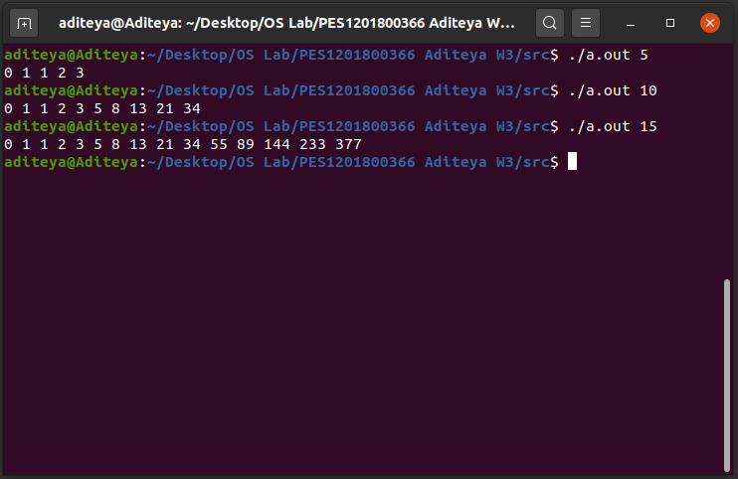

2. Question 2

Write a C program that uses the child to compute partial sums and parent to compute the partial products of an array of integers. Both child and parent should print the respective total sum and product values. Use an array with a minimum of 5 elements.

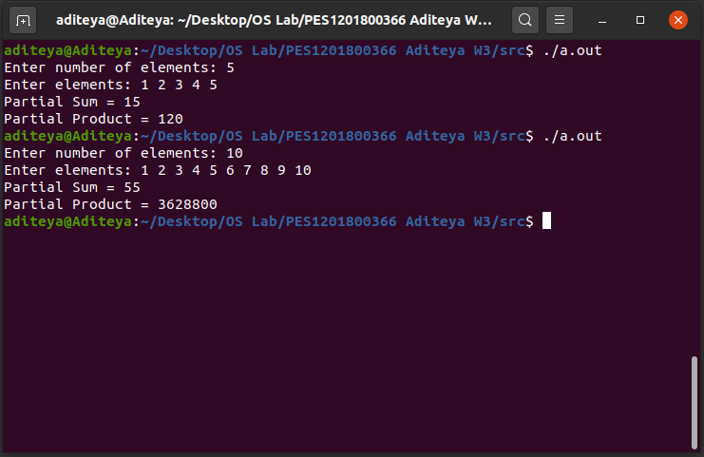

3. Question 3

Write a C program to demonstrate the use of fork(), exec() and wait() all in one program. Use any one of the family of exec system calls such as execl() or execvp().

Example: If the input/argument to the program is one of these: ls, ls –l, find, <executable_program> - then your program should display the output of the same command (like the output of “ls –l” command) or the executable_program that was passed as an argument.

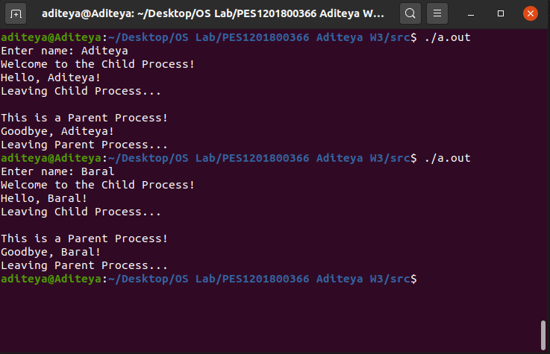

4. Questions